HTML Exercises W3SCHOOL

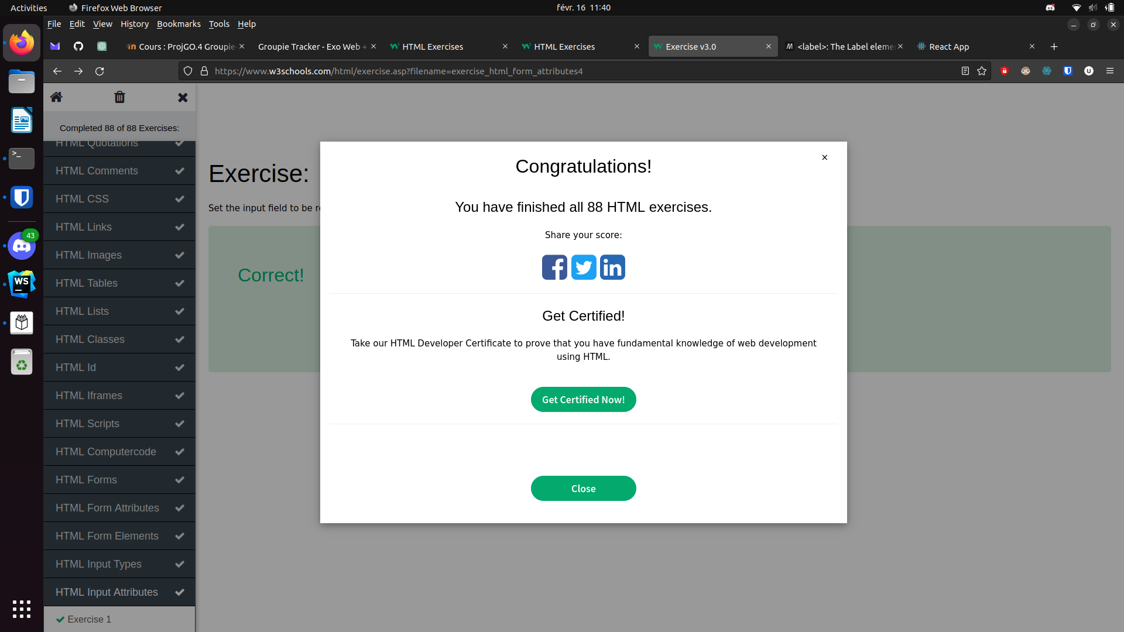

CSS Exercises W3SCHOOL



JavaScript Exercises W3SCHOOL
